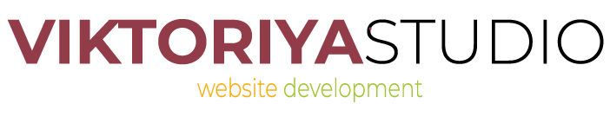

Brief on creation of a logo/banner/illustration
If you are having difficulties filling out this brief, please contact us in any way convenient to you and we will fill it out together with you. We thank you in advance for your time.

Contact information
Company name
Contact person
Contact phone number
Contact e-mail address
Viber
URLs of company’s websites (if any exist)

Company information

For how long has your business existed on the market?

What are your company’s geographic market area and industry domain?

Chief products and/or services

Describe your company’s advantages. What makes you different from your competitors? What makes you unique?

Are the things that you offer on the market familiar or novel to the consumer?

Describe your target audience. Are they private individuals or corporate clients? What are their main socio-demographic features (such as geographic area, age, social status, behavioural traits)?

Your company’s slogan (if one exists)
Contractor selection format: | ☐ Open auction ☐ Closed tender  ☐ Request for proposal  ☐ We are the sole contractor  ☐ Other (specify)

Project general information
Project’s name
Language versions
What problems is the development expected to solve?
Do you have a brand style that ought to be respected during development? Do you have a brandbook?
Where is your logo/banner/illustration going to be seen most frequently by the consumer? | ☐ Website  ☐ Clothing  ☐ App  ☐ Presentation  ☐ Package  ☐ Label  ☐ Other printed produce  ☐ For personal use
Do you have an old logo? If yes, why doesn’t it suffice anymore or why was a decision made to get a new one?
Give examples of logos/banners/illustrations and styles of other brands that you consider successful from the point of view of suitability for the desired image of your brand, and explain why.

Project details
Your wishes regarding size and format of the logo/banner/illustration. Other technical requirements.
Description of the image (appearance), description of the project. Attach a sketch if you have got one.
What colours to use and what colours to avoid? If there exist strict limitations or needs regarding colour use they must be specified.
Stylistical preferences. If you have any, list your wishes regarding the general style, colours, possibility of using specific images in models, fonts. What styles do you like - calligraphy, ethnic, minimalism, abstract, painted, childlike, photorealistic etc.?
What associations and images should your brand evoke in a client who sees it? / What emotion do you sell?
What kind of character should the logo/banner/illustration have? | ☐ businesslike  ☐ youthful  ☐ romantic  ☐ expressive  ☐ other
Should any additional sensemaking techniques be applied? Humour, épatage etc.
What objects, processes or effects must be displayed in the logo/banner/illustration? For example, lightning, Doppler effect, lighting effects, animation etc.
What kinds of associative images should be used in design?
What kinds of images and design solutions, in your opinion, are unacceptable to use, and why?
Are there any specific icon or text elements that must be used in the project? List them and specify when you are going to provide them.

Type of the logo
Which of the following logo types is, in your opinion, best suited for the image of your brand? (choose and put a checkmark):
☐  Combination: icon and text side by side | 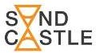  ☐  Integration: icon integrated into text | 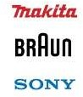  ☐  Text only, single font | 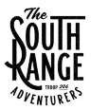  ☐  Text only, multiple fonts
☐  Icon only | ☐  Mascot | ☐  Emblem | ☐  Coat of arms
☐  Monogram | ☐  Ligature | 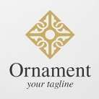  ☐  Ornament

Style of the logo
Which of the following logo styles is, in your opinion, best suited for the image of your brand? (choose and put a checkmark):
☐ Form & counterform

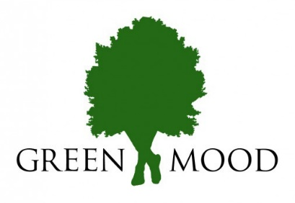
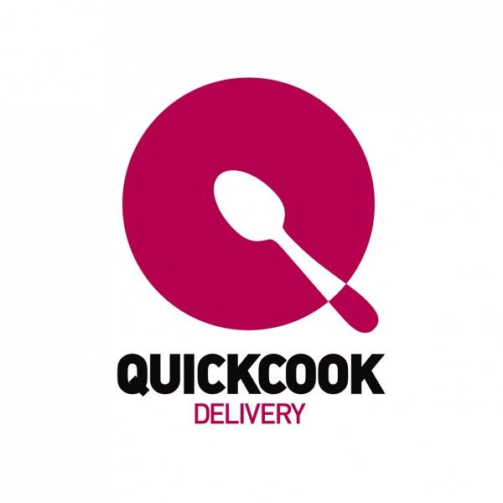
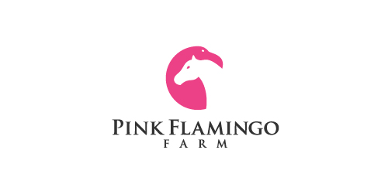

☐ Allegory / Metaphor
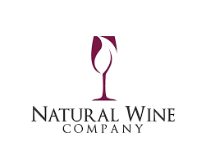
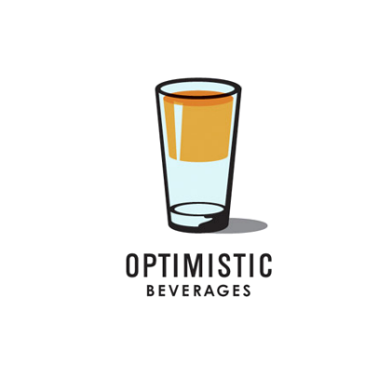
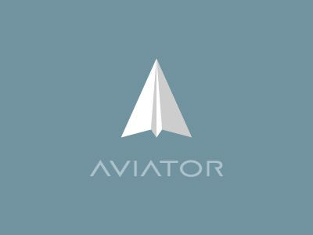

☐ Calligraphy
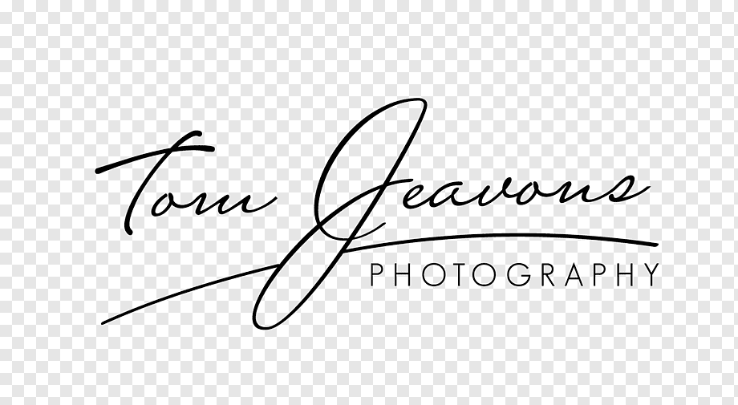
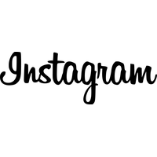
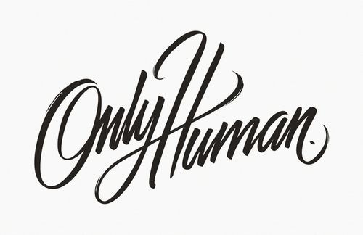
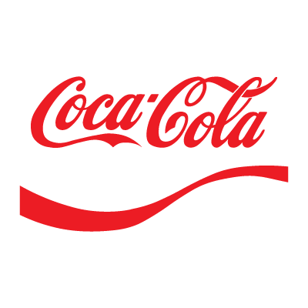

☐ 3D effect / Photorealism

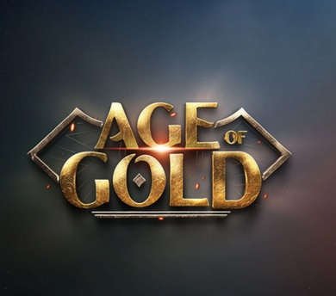
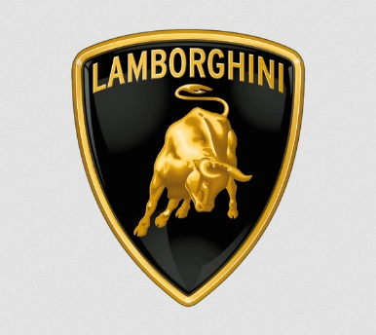
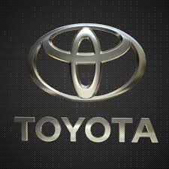

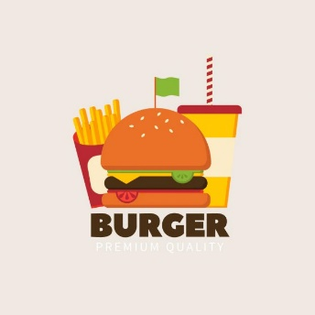
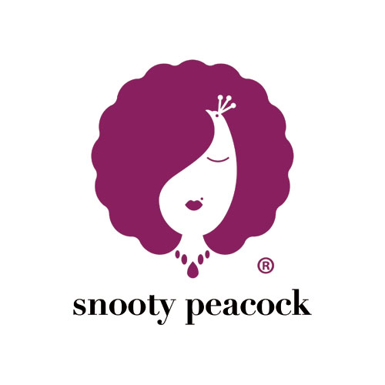
☐ Flat
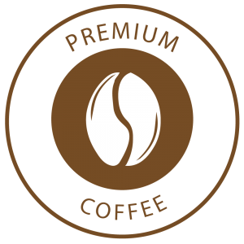
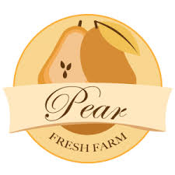

☐ Majestic
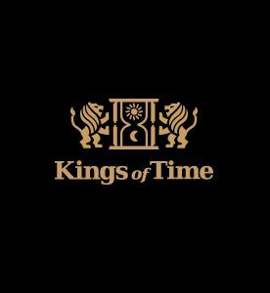
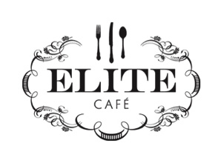
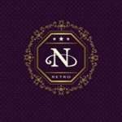
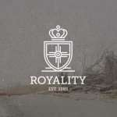

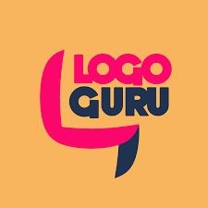
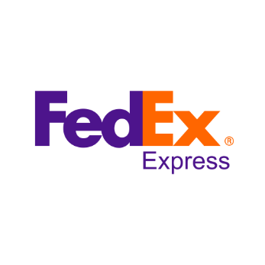
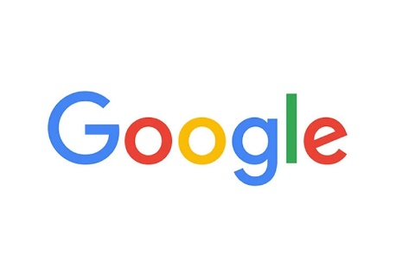
☐ Typography

☐ Humourous
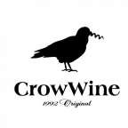
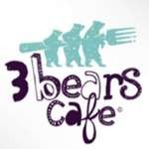
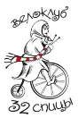
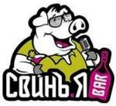

☐ Gradient / Transparence
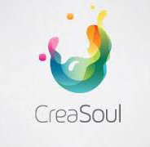
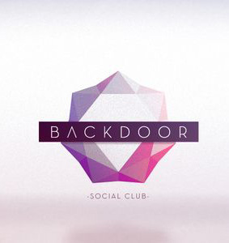
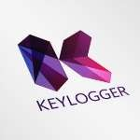

☐ Painted

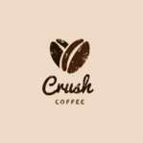
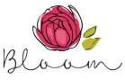
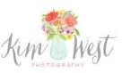

☐ Abstract
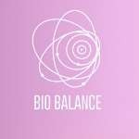
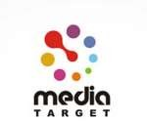

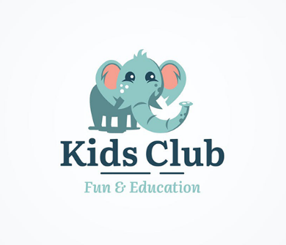
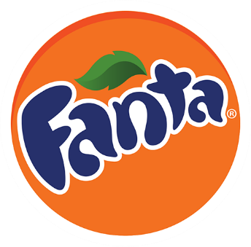
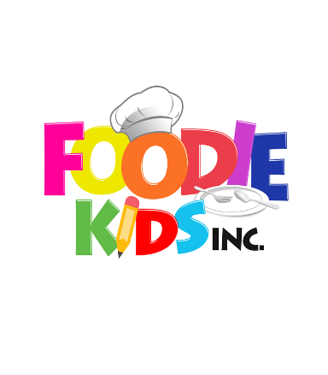
☐ Childlike
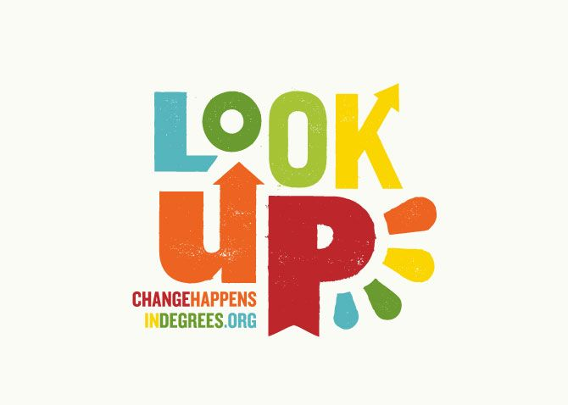

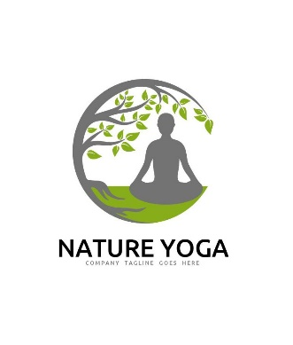
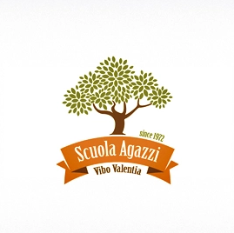
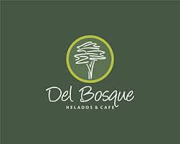
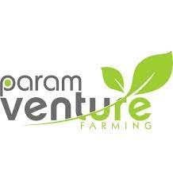
☐ Natural

Budget and deadlines
Specify a lower and an upper bound to the estimated budget for developing the logo/banner/illustration
Specify a desired delivery deadline for the project

Additional information
Any information that will aid us in our work on the project

After completing the brief please send it to address
sale@web-designing.top
You may attach other files and documents to your message if needed.

